**DATABASE ARCHITECTURE**

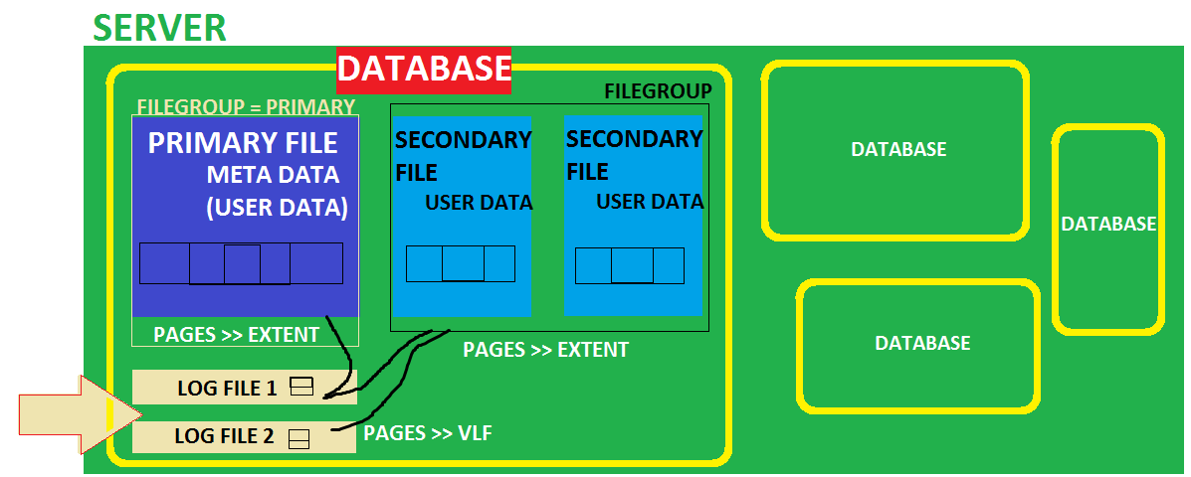

**DATABASE** IS PHYSICALLY A COLLECTION OF "FILES".

**PURPOSE**: FOR EASY STORAGE, MANAGEMENT & RECOVERY.

**TYPES OF FILES**:

**1**. **ROWS DATA FILES** - TO STORE THE ACTUAL DATA FOR THE DATABASE. TABLE DATA.

a. **PRIMARY DATA FILE**: THIS IS MANDATORY.

TO STORE METADATA [PROPERTIES] OF DATABASE + USER DATA (.mdf)

b. **SECONDARY DATA FILE**: THIS IS OPTIONAL. THESE ARE MANUALLY ADDED.

TO STORE USER DATA (.ndf). USED FOR VERY BIG DATA STORAGE.

**2. LOG FILE(S)** -TO STORE AUDIT INFORMATION = **TLOG FILE** = **TRANSACTION LOG FILE** (.ldf)

EVERY DATABASE SHOULD HAVE ATLEAST ONE PRIMARY DATA FILE + ONE LOG FILE.

**DATA FILES:**

EVERY DATA FILE IS MADE UP OF INTERNAL PAGES. SIZE OF EACH PAGE: 8 KB.

A COLLECTION OF 8 CONSECUTIVE PAGES IS CALLED “EXTENT”. SIZE OF EXTENT : 64 KB.

**TYPES OF EXTENTS :**

**UNIFORM EXTENT :** ALL 8 PAGES OF THE EXTENT PERTAIN TO SAME TABLE.

MIXED EXTENT : FEW PAGES PERTAIN TO ONE TABLE, REMAINING PAGES

@ OTHER TABLE.

**LOG FILES:**

EVERY LOG FILE IS MADE UP OF INTERNAL PAGES. SIZE OF EACH PAGE: 8 KB.

A COLLECTION OF FEW PAGES IS CALLED “VIRTUAL LOG FILE (VLF)”.

**SCHOOL** **DATABASE**

WATCHMEN LOG FILES

GROUND FLOOR PRIMARY FILEGROUP

RECEPTION PRIMARY FILE

CLASSROOM 1 SECONDARY FILE 1

CLASSROOM 2 SECONDARY FILE 2

1ST FLOOR SECONDARY FILEGROUP

CLASSROOM 3 SECONDARY FILE 3

CLASSROOM 4 SECONDARY FILE 4

2ND FLOOR SECONDARY FILEGROUP

CLASSROOM 5 SECONDARY FILE 5

CLASSROOM 6 SECONDARY FILE 6

CHAIRS PAGES (8KB)

**SERVER CONTAINS DATABASE**

**DATABASE CONTAINS FILEGROUPS**

**FILEGROUPS CONTAIN FILES**

**FILES CONTAIN PAGES**

**PAGES CONTACT ACTUAL DATA.**

-------------------------------------------------------------------------------------------------------------------------------

**STEP** 1: LAUNCH SSMS > CONNECT TO YOUR SQL SERVER

**STEP** 2: RIGHT CLICK DATABASES > NEW DATABASE

SPECIFY A NAME

WE SEE TWO FILES AUTO CREATED : 1 PRIMARY DATA FILE + 1 LOG FILE

WE CAN MODIFY THESE FILES NAMES, SIZE AND LOCATION.

**STEP** 3: CLICK @ "ADD" BUTTON YOU SEE AT BOTTOM RIGHT SIDE > SPECIFY NAME, LOCATION.

**STEP** 4: FROM "FILEGROUP" COLUMN > DROPDOWN > NEW FILEGROUP > NAME> OK.

**STEP** 5: **TO ADD ADDITIONAL LOG FILE:**

CLICK @ "ADD" BUTTON YOU SEE AT BOTTOM RIGHT SIDE > CHANGE TYPE OF THE FILE FROM "ROWS DATA" TO "LOG".

**STEP** 6: TO SEE TSQL SCRIPT FOR ALL ABOVE OPERATIONS:

CLICK @ "**SCRIPT**" BUTTON YOU SEE ON TOP > LEFT SIDE OF "NEW DATABASE" SCREEN.

**STEP** 7: CLICK "OK" TO CREATE THE DATABASE.

**STEP** 8: TO MODIFY THE STRUCTURE OF THE DATABASE?

FROM SSMS > CONNECT TO YOUR SERVER > RIGHT CLICK ABOVE DATABASE >

PROPERTIES > ADD FILES / RENAME FILES / ADD FILEGROUPS

**How to use above created File Groups and Partition the database?**

CREATETABLE TBLACCOUNTS

(

ACCID INT,

ACCBAL FLOAT

) ON ACC_FILEGROUP -- THIS TABLE DATA WILL BE STORED IN D$

CREATETABLE TBLINSURANCE

(

INSID INT,

INSBAL FLOAT

) ON INSURANCE_FILEGROUP -- THIS TABLE DATA WILL BE STORED IN E$

/*

Server

Database

File Group

Data Files

Table Data

*/